DIS-EUR-VINCA-Conjoined Body

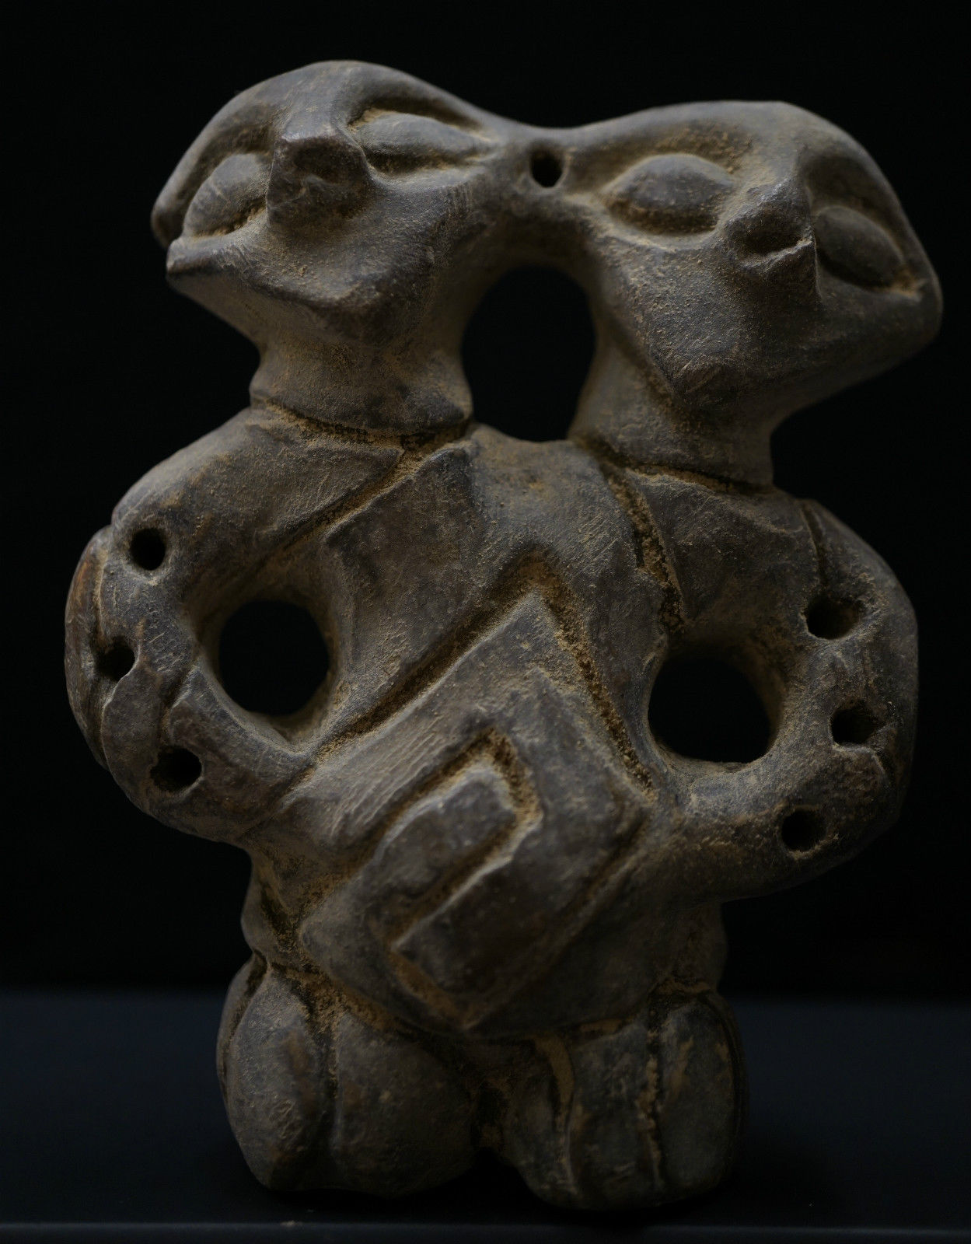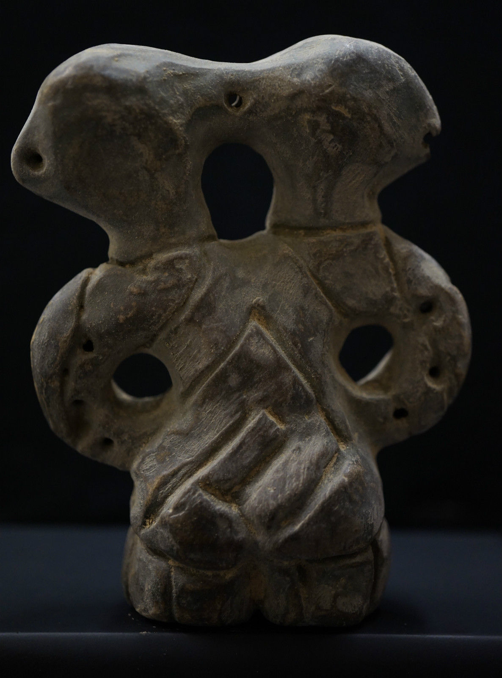

**Double-headed figure or statuette of a couple.**

**Clay / Ceramics. Vinca-Plocnik Culture, Late Mesolithic (5th mill. BCE).**

**---EXTREMELY RARE---**

---VERY RARE & BEAUTIFUL---

Condition: **MINT. MUSEUM QUALITY.** **Just as seen on the photos.**

Material: **Ancient Clay / Ceramics. Uncleaned. Just as excavated.**

WEIGHT: **89.8 g**

SIZE: **About 85 mm. Just as seen on the photos.**

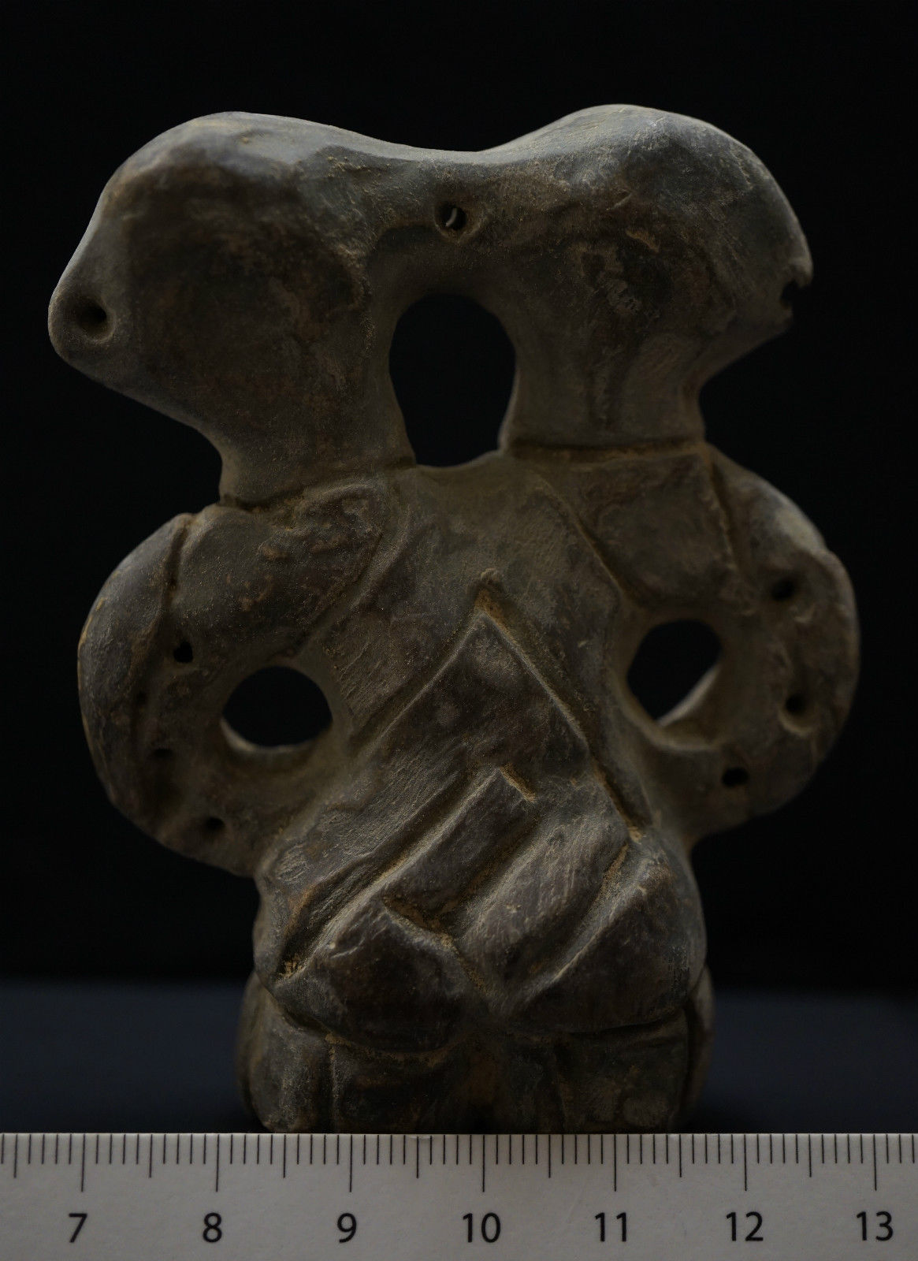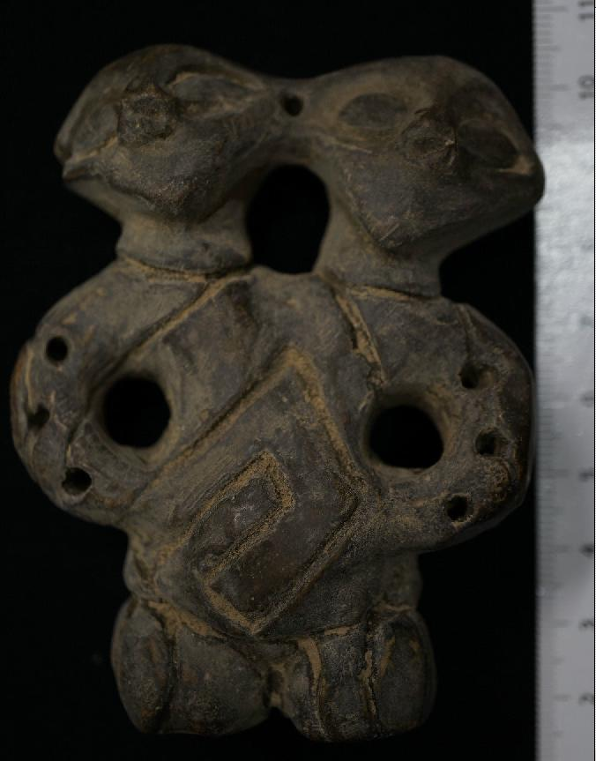

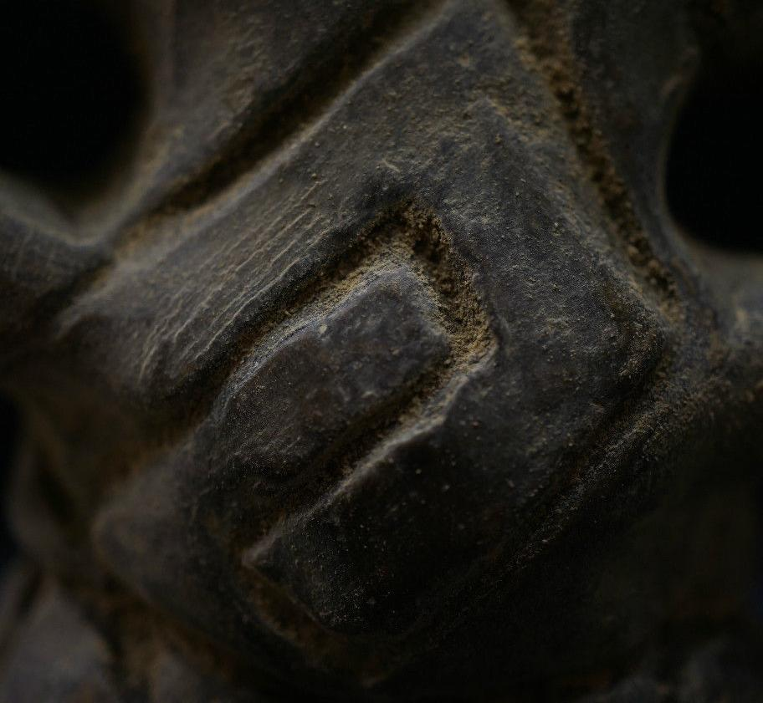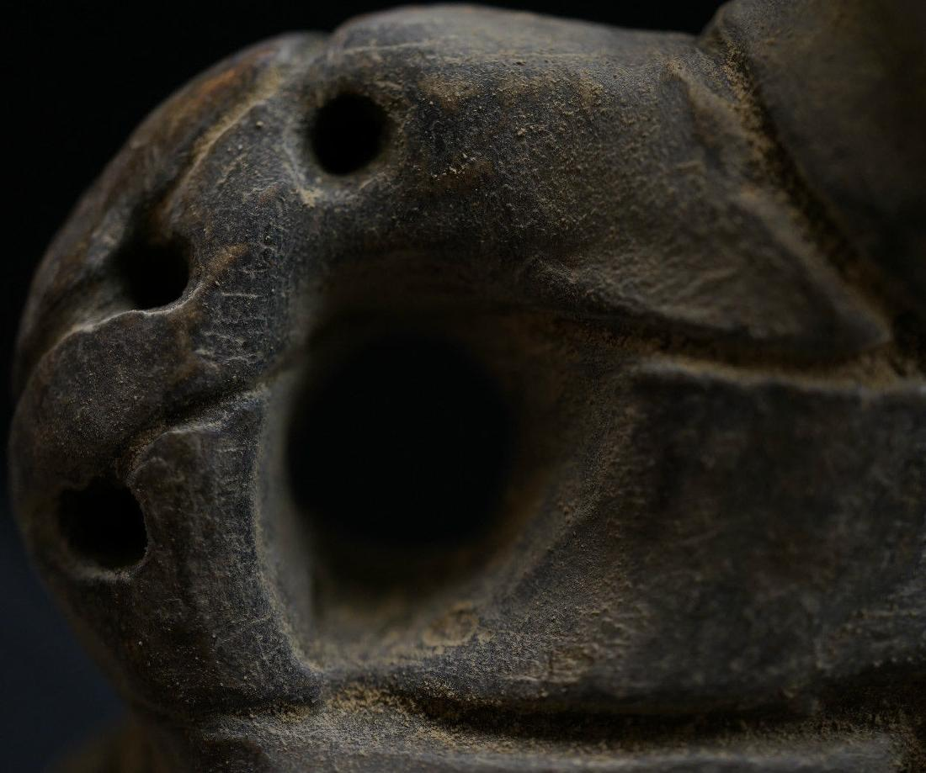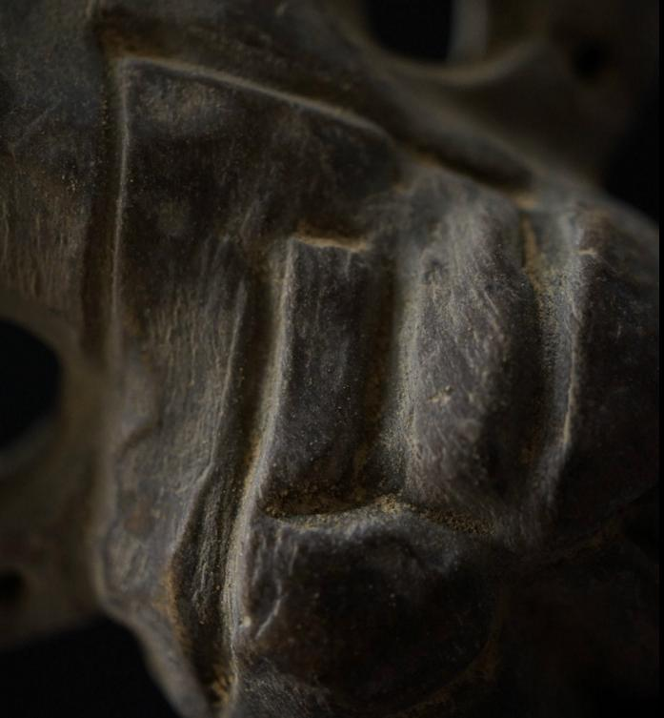

### Delivery package 1 of 1

Estimated delivery Wednesday, 13. Jul. 2016 -Thursday, 21. Jul. 2016

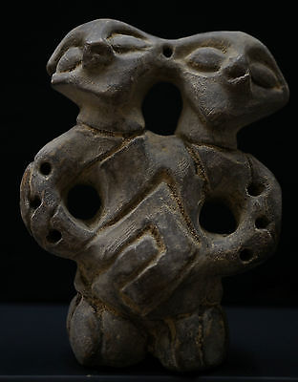

#### [Ancient Neolithic Cult STATUE FIGURINE of COJOINED BODY, circa 5000 BC. RARE. VF](http://www.ebay.co.uk/itm/222176825247)

|  |  |
| --- | --- |
| **Item price** | £ 240.00 |
| **Quantity** | 1 |
| **Item number** | 222176825247 |
| **Delivery service** | Royal Mail International Signed |

[Contact seller](http://contact.ebay.co.uk/ws/eBayISAPI.dll?FindAnswers&frm=3998&iid=222176825247&redirect=0&requested=pavloantiqueshop)

[Return item](https://www.ebay.co.uk/rtn/Return/ReturnViewSelectedItem?transactionId=0&itemId=222176825247&_trksid=p2057872.m2749.l3185)

## Delivery address

Ralph J Coffman Jr

149 Atlantic Ave

Swampscott MA 01907-2427

United States

## Order total

|  |  |
| --- | --- |
| **Subtotal** | £ 240.00 |
| **Postage** | £ 8.99 |

**Total**

£ 248.99